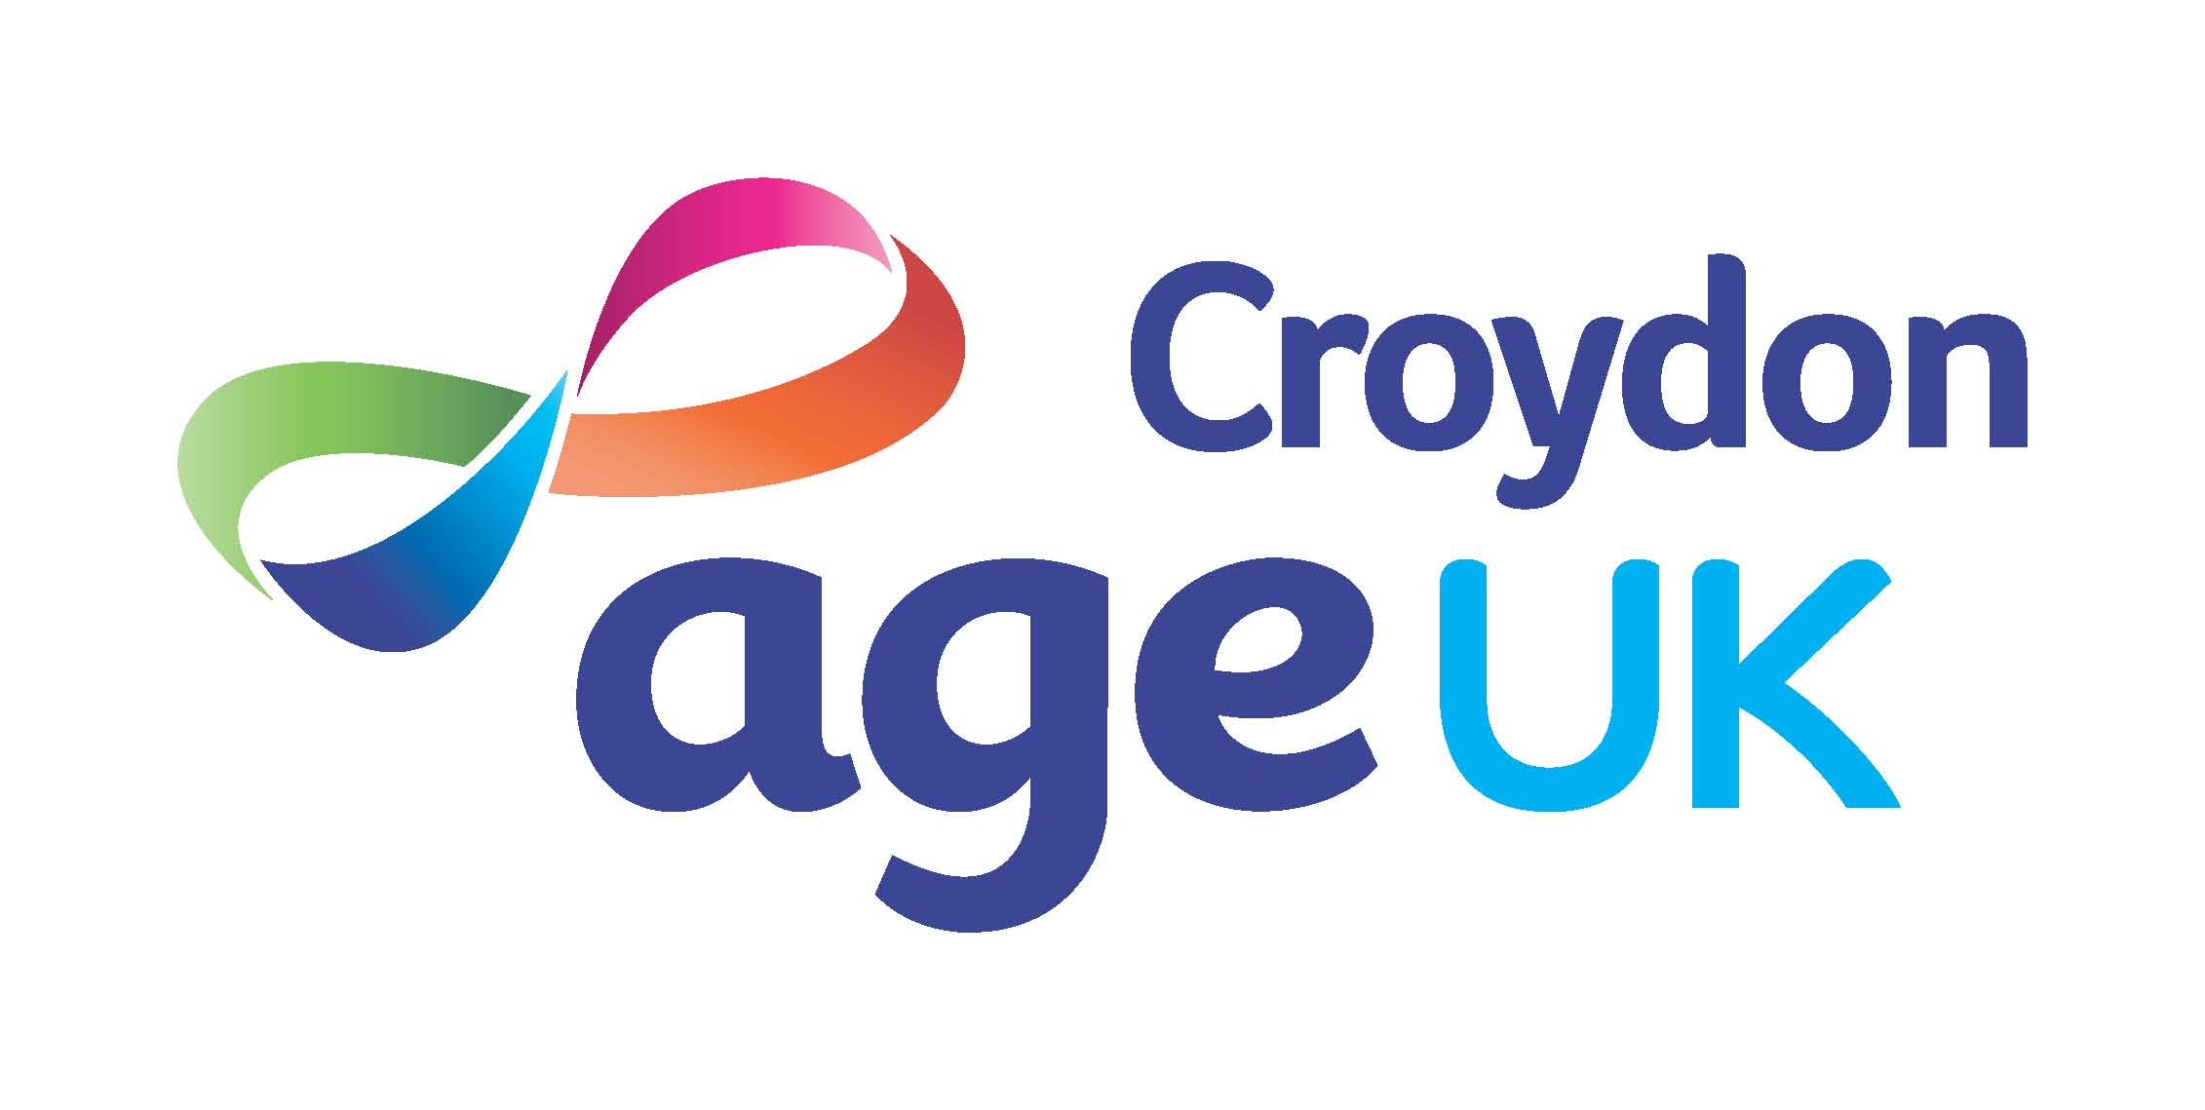
Healthier Lifestyles Project Officer
Job Description

Title: Healthier Lifestyles Project Officer

Responsible to: Healthier Lifestyles Manager

Responsible for: Volunteers, as required

Salary: £25,500 FTE.
Hours: 21 hours per week (Days to be Agreed)

Holiday: 28 days per annum, pro rata

Contract: Fixed term contract to July 2021 (possible extension
subject to funding)

Pension: Auto enrolment regulations apply

Location: Age UK Croydon, 81 Brigstock road, CR7 7JH
(Remote working expected)

Age UK Croydon has a vision where everyone can love later life. Our mission is to lead the way in empowering, enabling, supporting and connecting older people in the London Borough of Croydon to live well, healthily and independently.

We are guided by our values Integrity, Empowerment, Trust, Compassion and Collaboration.

The Healthier Lifestyles Team at Age UK Croydon offers activities and events across the borough of Croydon combining, exercise, health checks, health promotion talks and social engagement in a variety of local settings. These sessions aim to; reduce isolation; improve independence; reduce the risk of falls; increase health & fitness; motivate people to take control of modifiable factors that influence improved health and well being

.
We also run the Memory Tree Café, where we provide an accessible hub to support people with memory problems or a diagnosis of dementia. The hub combines reminiscence, exercise, activity and social interaction and is a service we are looking to grow and extend.

In March 2020 the service had to adapt quickly to COVID19 and we now offer a mixture of online Zoom sessions and telephone support to clients. Online classes have proved successful and we envisage that going forward the service will offer sessions both online and back out in the community when this can be done safely.

We are looking for an additional advisor to help grow our service. If you are passionate about making a difference to the lives of the older people who use our services, and those who care for them and want to contribute to an organisation which is continuously striving to improve, then we would love to hear from you.

Main Duties and key tasks:

- Delivering health hub sessions aimed at older Croydon residents either online or out in the community. During sessions you will deliver exercise to groups, provide mini health checks (subject to training and relaxation of COVID19 restrictions), deliver health promotion talks or work with other organisations to deliver talks/activities, provide information and motivation around modifiable risk factors for improved health and well being.

- Support clients over the phone, especially those who are digitally isolated. Encourage people to become more engaged with technology so they can get more from the service. Get involved with AUKC’s digital inclusion initiatives.

- Work closely with other team members to organise, plan, develop and promote the service.

- Provide occasional home visits to clients who are unable to attend groups. For example those who are very frail/may be as risk of malnutrition. Referring on when appropriate.

Providing cover for the Memory Tree Dementia Café as required. This will involve delivering exercise, planning and delivering fun and appropriate activities for client with dementia, calling and emailing clients.

- Provide signposting and information on a range of healthy lifestyle choices and screening programmes.

- Promote healthy lifestyle options for older people in Croydon through these initiatives, including culturally related approaches to strengthen communities. .

- Undertake training;
- - to maintain an up to date awareness of current health improvement initiatives and ensure that these are incorporated within the service. ;

- - that may be necessary as the project changes, for example training to deliver a different type of exercise

- Work together with different types of volunteers (outreach and administrative ). Mentor, supervise and support them to enable them to reach their potential and goals. .

- Maintain an awareness of health and safety issues associated with the project.

- Publicise and promote the service within the community.

- Establish links with health professionals, voluntary, statutory and private sector providers, to promote the service and enable effective partnership working and maximise local resources.

- Keep accurate records, case notes and write reports, ensure equipment is ready for events, including necessary paperwork prepared and ready for events.

- Maintain financial records as required in line with policies and procedures

- Maintain information for the monitoring and evaluation of the project in accordance with Age UK Croydon, and funder’s requirements.

- Attend training, meetings, steering groups and supervision appropriate to the post and Age UK Croydon.

- Comply with all Age UK Croydon policies and procedures with particular regard to Equal Opportunities, Health and Safety and Confidentiality.

- Undertake other appropriate duties as required by the Line Manager.

